# 

# **Department of Computer Science and Engineering Islamic University of Technology (IUT)** A subsidiary organ of OIC

# 

# **Laboratory Report**

# CSE 4412 : Data Communication and Networking Lab

## 

## **Name: Md Muktadir Mazumder Student ID: 190042136 Section: Lab Group B Semester: 4th Semester Academic Year: 2021-22**

**Date of Submission: 02/02/2022**

### **Title:** Configuration of RIP in a network topology.

### **Objective**:

1. Understand distance vector routing
2. Understand RIP
3. Understand the necessity of dynamic routing

### **Devices/ software Used**:

1. Device: Personal Computer

2. Software: Cisco Packet Tracer

### **Theory:**

**Distance Vector (DV) Routing**

In the distance vector routing, the least-cost route between any two nodes is the route with minimum distance. In this protocol, each node maintains a vector (table) of minimum distances to every node. The table at each node also guides the packets to the desired node by showing the next stop in the route (next-hop routing). In distance vector routing, each node shares its routing table with its immediate neighbors periodically and when there is a change. The distance vector algorithm is iterative, asynchronous and distributed. Besides this algorithm is dynamic and each router maintains a distance table which is known as vector.

**Count to Infinity problem in DV routing**

Bellman ford algorithm is a single-source shortest path algorithm. This algorithm is used to find the shortest distance from the single vertex to all the other vertices of a weighted graph.

***A--------------B------------C***

The Bellman-Ford algorithm will converge for each router, they will have entries for each other.

B will know that it can get to C at a cost of 1, and A will know that it can get to C via B at a cost

of 2.

***A--------------B-----M------C***

If the link between B and C is disconnected, then B will know that it can no longer get to C via that link and will remove it from it’s table. Before it can send any updates it’s possible that it will receive an update from A which will be advertising that it can get to C at a cost of 2. B can get to A at a cost of 1, so it will update a route to C via A at a cost of 3. A will then receive updates from B later and update its cost to 4. They will then go on feeding each other bad information toward infinity which is called the Count to Infinity problem.

**Two node Loop problem in DV routing**

***A--------------B------------C***

The Bellman-Ford algorithm will converge for each router, they will have entries for each other.

B will know that it can get to C at a cost of 1, and A will know that it can get to C via B at a cost

of 2.

***A--------------B-----M------C***

If the link between B and C is disconnected, then B will know that it can no longer get to C via that link and will remove it from it’s table. Before it can send any updates it’s possible that it will receive an update from A which will be advertising that it can get to C at a cost of 2. B can get to A at a cost of 1, so it will update a route to C via A at a cost of 3. A will then receive updates from B later and update its cost to 4. They will then go on feeding each other bad information toward infinity. At this moment, both A and B know that C cannot be reached. However, during this time the system is not stable. Node A thinks that the route to C is via B; node B thinks that the route to C is via A. If A receives a packet destined for C, it goes to B and then comes back to A. Similarly, if B receives a packet destined for C, it goes to A and comes back to B. Packets bounce between A and B, creating a two-node loop problem.

**Split Horizon (one solution to instability)**

***A--------------B-----M------C***

If the link between B and C goes down, and B had received a route from A , B could end up using that route via A. A would send the packet right back to B, creating a loop. But according to Split horizon Rule, Node A does not advertise its route for C (namely A to B to C) back to B. On the surface, this seems redundant since B will never route via node A because the route costs more than the direct route from B to C.

**Poison Reverse ()**

In a computer network that uses the Routing Information Protocol or other distance vector routing protocols, a poison reverse is a way in which a gateway node tells its neighbor gateways that one of the gateways is no longer connected. To do this, the notifying gateway sets the number of hops to the unconnected gateway to a number that indicates "infinite".Split horizon with Poison reverse technique is used by Routing Information Protocol (RIP) to reduce routing loops.

**Routing Information Protocol (RIP)**

RIP stands for Routing Information Protocol. RIP is an intra-domain routing protocol used within an autonomous system. It’s a dynamic routing protocol which uses a hop count as a routing metric to find the best path between the source and destination.

**Forwarding Table used in RIP**

A forwarding table or MAC table, is most commonly used in network Bridging ,routing and similar functions to find the proper output network interface to which the input interface should forward a packet. It is a dynamic table that maps MAC addresses to ports.

**Hop Count as cost**

Hop count is the number of routers occurring in between the source and destination network. The path with the lowest hop count is considered as the best route to reach a network and therefore placed in the routing table. RIP prevents routing loops by limiting the number of hops allowed in a path from source and destination. The maximum hop count allowed for RIP is 15 and hop count of 16 is considered as network unreachable

**Timers in RIP**

Three timers are used in RIP. Those are mentioned below:

1. Periodic timer: *Controls the sending of messages.*
2. Expiration timer: *Governs the validity of a route*.
3. Garbage collection timer: *Advertises the failure of a route.*

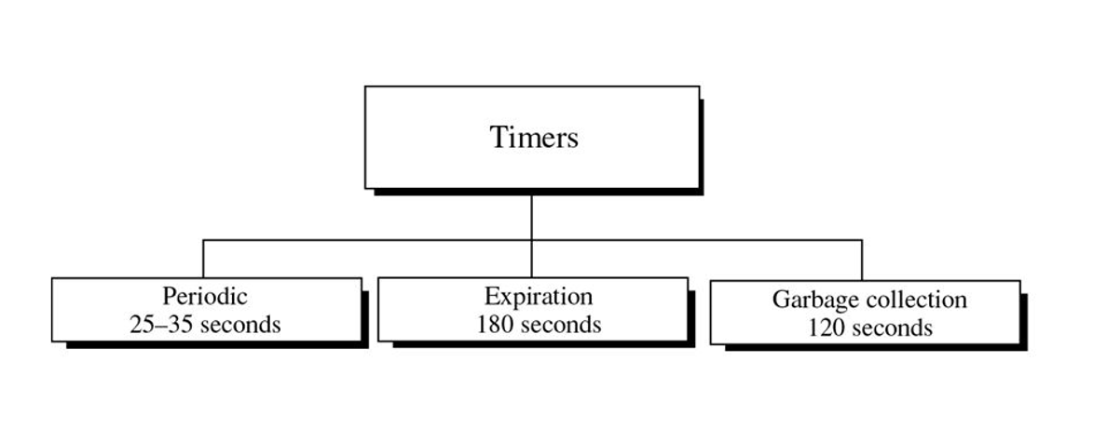

### **Diagram of the experiment:**

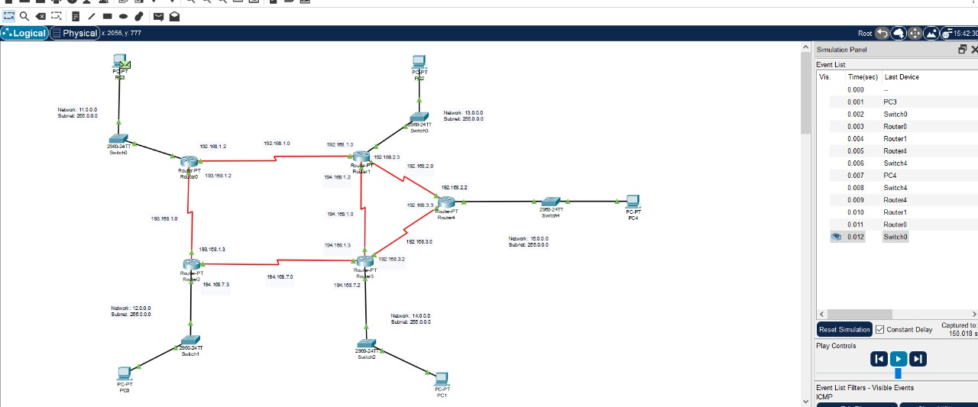

**Configuration of Routers:**

Commands for configuring RIP--->

**For Router 0:**

router rip

version 2

network 11.0.0.0

network 192.168.1.0

network 193.168.1.0

**For Router 1:**

router rip

version 2

network 13.0.0.0

network 192.168.1.0

network 192.168.2.0

network 194.168.1.0

**For Router 2:**

router rip

version 2

network 11.0.0.0

network 192.168.1.0

network 193.168.1.0

**For Router 3:**

router rip

version 2

network 14.0.0.0

network 192.168.3.0

network 194.168.1.0

network 194.168.7.0

**For Router 4:**

router rip

version 2

network 15.0.0.0

network 192.168.2.0

network 193.168.3.0

### **Observation**:

***After setting up the RIP routing algorithm if Serial port Se3/0 of Router 4 is switched off then what are the changes occured in Routing information of the routers.***

***Before the change in the path:***

The packet was sent from PC3 to PC4 when it is routed through Se3/0 port of Router 4.

***After the change in the path:***

When the Serial Port Se3 of Router 4 was switched off. Now the packet from PC3 to PC4 went to Router 1 through Se3/0 of Router 3 and then went to Router4 through Se6/0 port of Router 3 (Enters in Router4 via it’s se2/0 port). The packet was re-routed.

### **Challenges:**

### Alhamdulillah, the experiment was successful. But some problems were faced during the session, like the packets were not going successfully because I had not set the default gateway of the PC**s** and had to wait for 20 seconds or 1 minute to send the packet.